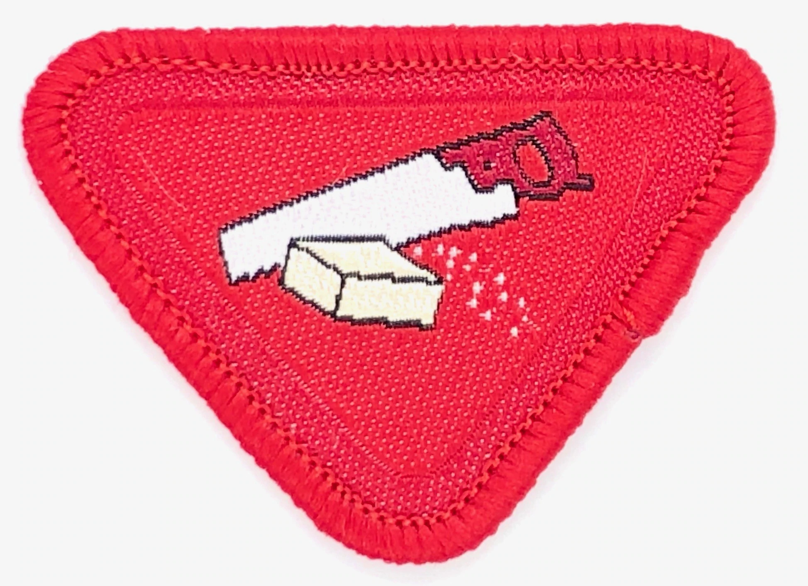
Carpenter Award

    - Explain the work of a carpenter.

    - Name three things that a carpenter build.

    - Read the following texts and tell what each carpenter built.
      - Genesis 6:14-16
      - Exodus 30:1-3
      - 2 Samuel 5:11

    - Identify the basic tools required for simple woodworking and explain how to take care of them.

    - Visit one of the places listed below:
a) Lumber Yard
b) Hardware Store
c) Woodworking Shop
d) Sawmill

    - Use carpentry tools to make one of the following:
      - Birdhouse or feeder
      - Key holder
      - Napkin holder
      - Another useful wooden object

    - Discuss Jesus the carpenter and the items he made.

