Coal Honor – Question Sheet

- What is coal?

- Why is coal considered a fossil fuel?

- Explain how coal is created. Read Genesis 7 – 8:1.

4. Compare and contrast the four main types of coal, correctly identity their unique features, and the BTU’s they produce.

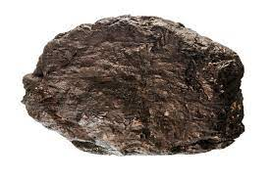
- ___
- ___
- ___
- ___
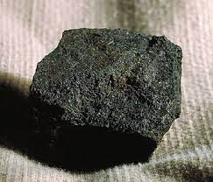
- ___
- ___
- ___
- ___

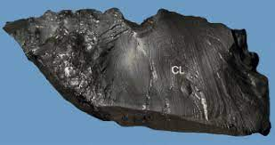
- ___
- ___
- ___
- ___

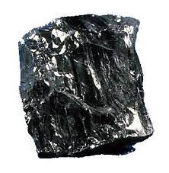
- ___
- ___
- ___
- ___

- Lignite Coal
- Anthracite Coal
- Subbituminous Coal
- Bituminous Coal
- This coal has between 45-85% carbon
- This coal has between 25 - 35% carbon.
- This coal has the highest percentage of carbon (86-98%) with the lowest volatile matter
- This coal has between 35 -45% carbon.
- It has a soft dull (lighter) black appearance.
- It is a hard and brittle coal with a black lustrous look.
- It is blocky in appearance with alternating layers of dull and shiny layers.
- It is also known as brown coal.
- It has the less percentage of carbon and the lowest BTU value with up to 70% water.
- It produces around 8,500 – 13,000 BTU’s.
- It produces around 13,000 – 15,000 BTU’s.
- Its BTU range is between 11,000-15,000.
- It is used for both steel making and electrical generation power plants.
- It is used mainly for electrical generation power plants
- It is used to make coke, which is used for steel making.
- Its low-to-moderate heating values is mainly used for electrical generation power plants

5. List 5 major historic uses of coal.

6. List 3 advantages and 3 disadvantages of using coal as a fuel

7. Describe the 3 main methods that are used to mine for coal.

8. Discuss 3 major hazards of underground coal mining and what is done to reduce them.
- Evaluate the environmental impact concerns and restoration processes used in surface type coal mining.
10. Do one of the following and write a one-page review of what you learned from the visit.

a) Tour a coal mine

b) Visit a coal mining museum

c) Watch a video on the mining of coal

Skill Level 1

