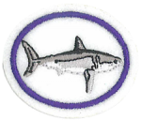
Sharks Honor Answer Sheet
- On what day of Creation Week were sharks created?

Genesis 1;20-23 (NKJV)

Then God said, “Let the waters swarm with fish and other life. Let the skies be filled with birds of every kind.” So God created great sea creatures and every living thing that scurries and swarms in the water, and every sort of bird—each producing offspring of the same kind. And God saw that it was good. Then God blessed them, saying, “Be fruitful and multiply. Let the fish fill the seas, and let the birds multiply on the earth.”
And evening passed and morning came, marking the fifth day.

- What is the study of sharks called?

The study of the subclass of fish known as cartilaginous (skeleton made from cartilage like in your nose, with no bones) including sharks, rays, and skates is called Elasmobranchology. These fish are collectively called the elasmobranchii.

- Identify from pictures or personal observation 10 species of sharks and what makes them a shark

- Cartilaginous skeleton (cartilage not bone)
- 5 – 7 gill slits on the sides of the head (breathe through)
- Pectoral Fins (not fused to the head)
- Replaceable teeth
- Dermal denticles & Parasites (protects the skin)
- Do not live-in freshwater
Except the bull shark and river shark (both sea and freshwater)

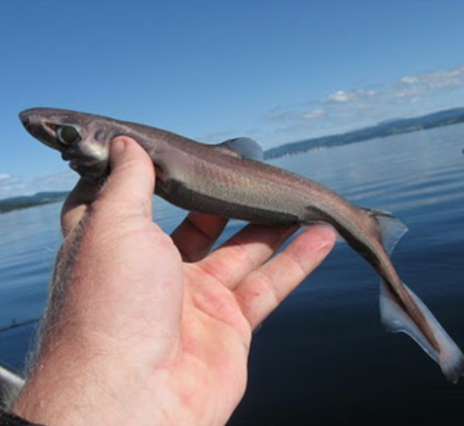
Dwarf Lanternshark

Where: Colombia and Venezuela

Description: Maximum length of 8.3 inches – smallest shark in the world

How does it look? Small size, long flat head, black markings and mid-dorsal line.
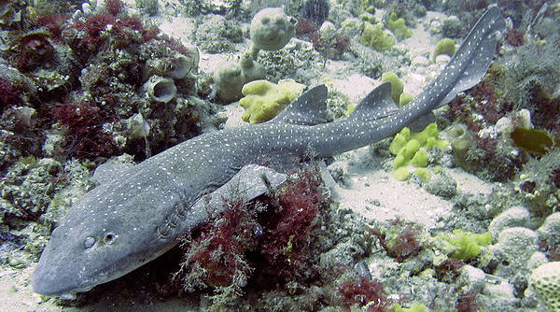

Blind Shark

Where: Eastern coast of Australia

Description: Not actually blind, closes its eyes when taken out of the water

Length: 24 -26 inches long

How does it look: Sticky, grayish to brownish body with white flects and darker bands that fade with age. Wide, flattened and blunt with small eyes on top and a pair of long barbels underneath
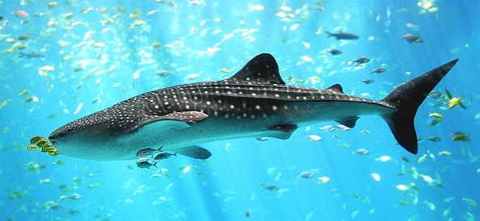
Whale Shark

Where: Tropical and warm oceans and lives in the open sea

Description: largest confirmed had a length of 41.5 ft

They can live up to 70 years

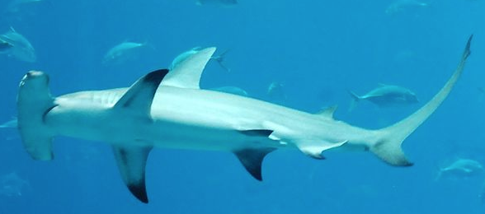
Great Hammerhead

Location: found in tropical and warm temperate water

Length: Maximum length of 20 ft

Description: can be distinguished by the shape of its “Hammer”, the fin is sickle-shaped

Great Hammerhead

Location: found in tropical and warm temperate water

Length: Maximum length of 20 ft

Description: can be distinguished by the shape of its “Hammer”, the fin is sickle-shaped
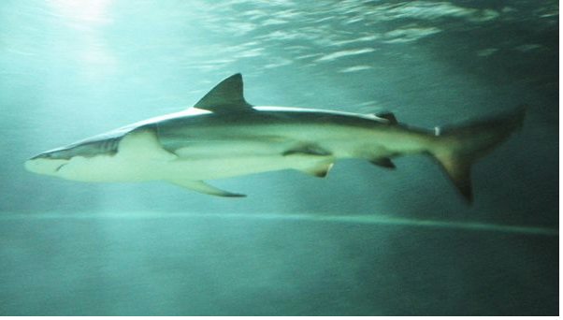

Copper Shark

Usually in temperatures more than 54 degrees

About 11 feet in length weighing in about 660 pounds

Copper sharks stay near the shoreline

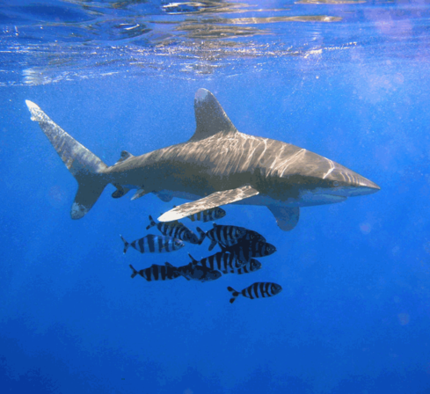
Oceanic Whitetip Shark

Likes water that is between 64 – 84 degrees Fahrenheit

Stocky body with a long white tipped fin

Its nose is round, and the eyes are circular

Becoming endangered because it is a main ingredient in shark fin soup

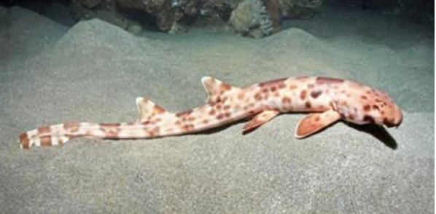
Indonesian Walking Shark

Named after the island of Halmahera Six of the nine known species of walking sharks are found in Indonesia.
Description: They get their name because they appear to walk along the sea floor. The walking sharks grow up to 27 inches long and are harmless to humans. Halmahera has a light brown color with leopard-like dark brown spots alternating with scattered white spots.

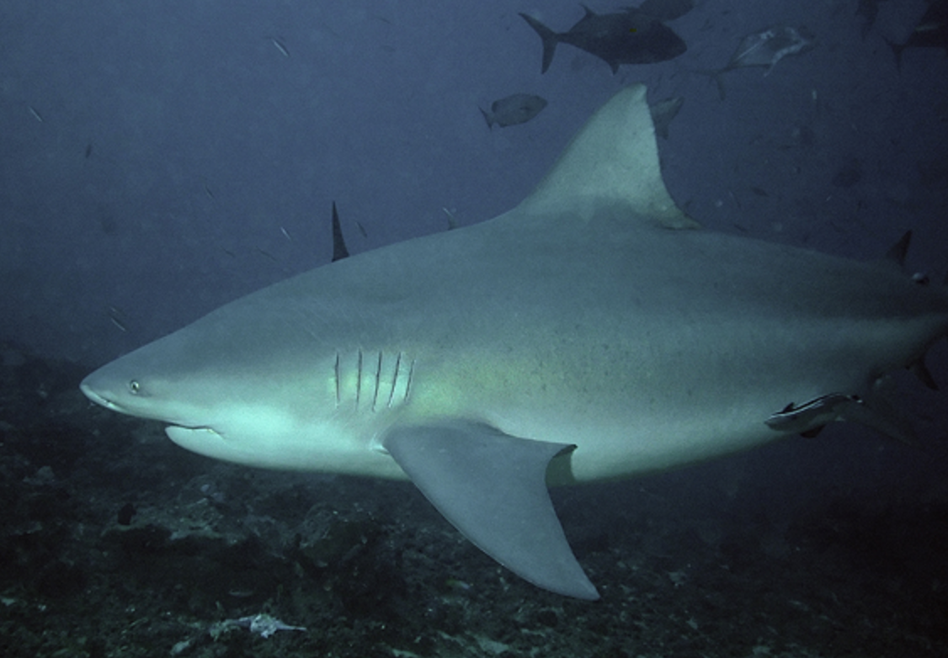
Bull Shark

Where found: The bull shark is commonly found worldwide in coastal areas of warm oceans, in rivers and lakes, and occasionally salt and freshwater streams if they are deep enough.
it is found from Massachusetts to southern Brazil, and from Morocco to Angola. In the Indian Ocean, it is found from South Africa to Kenya, India, and Vietnam to Australia.

Description: At 12 feet long, 650 pounds, the Bull Shark very closely resembles the Tiger Shark. Together with the Great White, these three species of shark account for 99% of annual shark attacks
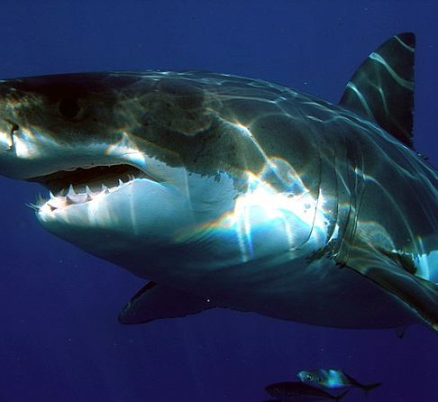

Great White Shark

Where found: Great white sharks live in almost all coastal and offshore waters which have water temperature between 12 and 24 °C (54 and 75 °F), with greater concentrations in the United States (Atlantic Northeast and California), South Africa, Japan, Oceania, Chile, and the Mediterranean. One of the densest known populations is found around Dyer Island, South Africa, where almost all of the shark research is done.

4. Draw a shark and identify the following shark parts:

1st Dorsal fin 2nd Dorsal fin Pectoral fin Pelvic fin
Anal fin Caudal fin Gill openings Spine
Eye Snout Nostril Mouth

Label the Shark Parts

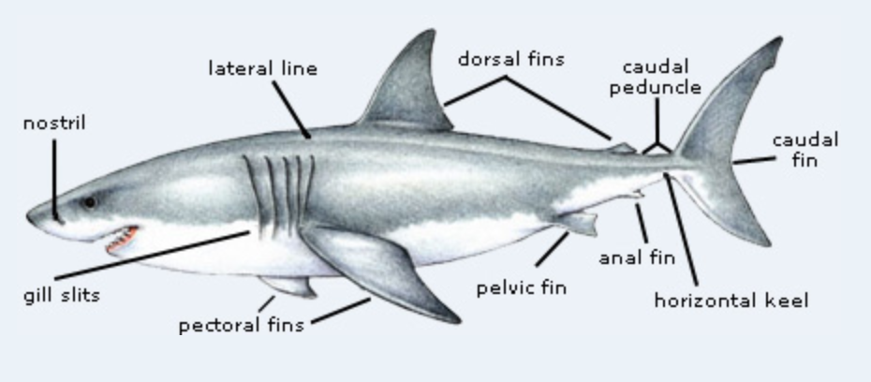

- Explain the shark sensory system: Smell, Sight, Taste, Hearing, Touch, Electroreception

- Smell - they use sound to locate food, they only have an inner ear, not attached to mouth
- Sight – they can see in dim light, sensitive to moving objects
- Taste – they have taste buds in their mouth, will spit out food that does not taste good
- Hearing – located in the frontal skull and all internal with a tiny opening on the shark’s
head
- Touch – sharks have free nerve endings in the skin, mouth, jaws and teeth
  - Electroreception - The Ampullae of Lorenzini are specialized pores consisting of a small chamber (the ampulla) and a sub-dermal canal which projects outward to the surface of the skin. The ampulla contains hundreds of sensory hair cells. The wall of the canal contains a double layer of connective tissue fibers and epithelial cells, which are tightly joined together to form a high electrical resistance between the inner and outer wall of the canal. The canal and ampulla themselves are filled with a high potassium, low resistance gel that forms an electrical core conductor with a resistance equaling that of seawater.

Fish carry an electrical charge different to that of seawater and so a weak voltage is created (by the movement of positive and negative particles moving back and forth shifting electrons in an attempt to become stable). Because the salt in the water contains both sodium and chlorine ions which can move freely in the water the electricity itself is transported, and this is what the ampullae of lorenzini is able to detect.

- Name the largest member of the shark family and its maximum adult size.

The Whale Shark

- Name the most aggressive member of the shark family.

Great White Shark

- Name the predators of the Great White Shark.
- Humans (fishing, boat collisions)
- Other Great White Sharks
- Rarely - Orca Whales

- Explain the shark breeding habits.

- Some sharks go back to the same breeding grounds every year.
- They can have a litter of up to 18 little sharks
- The mother gives birth then leaves them to fend for themselves

- How do sharks give birth?

- Some sharks lay eggs
- Some hatch eggs in the mother
- Others give birth to live young

11. Discuss with a group the following

- How to be safe when you are in a shark's natural environment

After watching some of the videos linked from this honor, you will see that shark safety depends on the type of shark you are with. If swimming with Great Whites you will want a shark cage. A chain mail suit can help prevent bites. White skin looks like fish, so a black wetsuit that covers everything helps. The blind shark might clamp on with jaws and suction to a person but is unlikely to cause real harm. Most sharks are completely harmless around humans.

- Misconceptions of sharks
- Sharks are dangerous! Some are, most are not. 80% of sharks are too placid or small to injure a person. Most live in deep water far from shore and are unlikely to encounter humans.
- Sharks have to keep swimming to breath (some do, some don't)
- Sharks will eat anything! Not so much. Sharks have specific diets they stick too. They use their senses including taste to figure out what is tasty food. If they taste a human (perhaps confused with a sea lion) they tend to release as soon as they realize the human is not their preferred meal.
- Sharks are difficult to kill! Not so much. A shark caught in a net or on a line may die from stress or exhaustion.

- Dangers of sharks
Shark attacks are one of the biggest fears among ocean swimmers (thanks to Hollywood!) but these fears are almost completely unjustified. Worldwide the number of shark attacks is usually under 10 per year. Riptides, drowning, even cuts from coral are all greater threats.
If you are actually swimming with sharks, take species appropriate precautions.
Humans are a far greater danger to sharks than sharks are a danger to humans. Tens of millions of sharks a year are victims of:
- By-catch: accidentally caught in nets intended other species
- Sport fishing for trophies
- Catch for food sources - shark fin soup, meat etc
- Illegal poaching

12. Do two of the following activities:

- Take a trip to a local aquarium and learn about the shark daily feeding schedule and
habits.

b. Watch a documentary about sharks and identify how sharks hurt and benefit humans.

c. Visit a natural history museum and observe how sharks are displayed within their
ecosystem.
d. Create a display of 10 photos and information about sharks including significant
information learned in this honor.
e. Create a game that assists others in learning about sharks. You may model the
game after popular card or board games.

