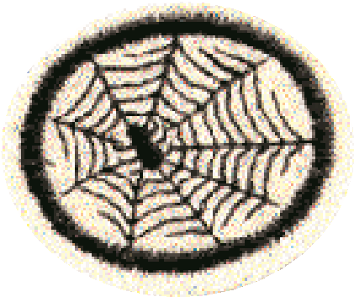
Pathfinder’s Name
Spooky Spiders

Identify Parts of a Spider:

A._____________________ D. ________________________
B. _____________________ E. ________________________
C. _____________________ F. ________________________
G. ________________________

2. What is the largest member of the spider family? ___________________

3. Give three ways in which spiders differ from insects.
1. ________________________________________________________
2. ________________________________________________________
3. ________________________________________________________

4. Make a careful drawing of an orb web.

5. What other kinds of webs are there besides the orb web?
1. ________________________________________________________
2. _________________________________________________________
3. _________________________________________________________

6. What do spiders eat?
Make a list of victims found in spider webs.
________________________________________________________________
________________________________________________________________
________________________________________________________________

7. For what is a spider web useful? ______________________________________
________________________________________________________________
________________________________________________________________

8. Find two references in the Bible to spiders and their webs.
1. _____________________________________________________
2. _____________________________________________________

9. What are the chief enemies of spiders? _________________________________
_________________________________________________________________
_________________________________________________________________

10. How do spiders:
a. Help us? __________________________________________________
___________________________________________________________
___________________________________________________________
b. Hurt us and our property? _____________________________________
___________________________________________________________
___________________________________________________________

Spooky Spiders
Date completed ____________ Instructor’s Signature ____________________ _{2002 Edition}

