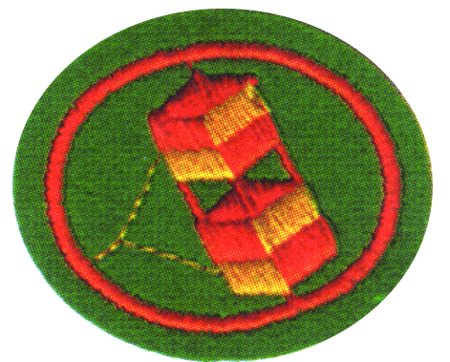
Kite Honor - Question Sheet
- What day of creation did God make flite creatures?

- When were kites first made and flown?

- Explain the principles of air dynamics.

- Lift & Gravity
- Thrust & Drag
- Pitch, Roll, and Yaw

- Explain the center of gravity and center of lift, and why this is important in kite design?
5. Define the following terms:

a. Spine(s) b. Spars
c. Vent d. Bowstring
e. Cover f. Frame
g. Tail h. Keel
i. Flying line j. Bridle
k. Reel l. Dihedral

- What are some types of kites used today?

- Tell the story of Benjamin Franklin and his kite in June 1752

- Name some of the ways that kites might be used today.

- What are the 4 what’s?

- What #1 – What is a common cause of kite failure?
- What #2 – If the line breaks what then?
- What #3 – What should be done when a kite loops during flight?
- What #4 – Do you know the safety rules for kite flying?

10. Make and successfully fly two of the following kites:
a. Sled kite
b. Flat kite
c. Two-stick diamond kite
d. Delta wing kite
e. Eddy or Malay kite
f. Box kite
g. Tetrahedral kite

