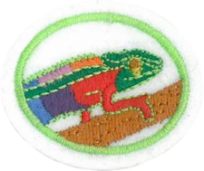
Animal Camouflage - NAD
Requirements

- Define the following terms as related to animals hiding in nature.

- Camouflage
- Adaptation

- Explain the purpose of Animal Camouflage.

- Describe and give an example of each of the following types of animal camouflage:

- Concealing coloration

- Disguise

- Mimicry

- Disruptive Coloration

- Do three of the following projects:

  - Create an animal of your own keeping in mind the use of animal camouflage.
  - create a game based on animal camouflage and play it with a group.
  - Write and tell a children’s story with an animal camouflage theme.
  - Spend a minimum of 30 minutes observing an animal with uses camouflage in its natural setting or a video and write a report on your observations.
  - Create a children’s book with illustrations about animal camouflage.
  - Create your own project about animal camouflage (get approval from your Club Director first)

- Discover how Satan uses disguise to deceive people and Jesus’ plan of redemption.

