Coal Honor – Answer Sheet

1 – What is coal?

It is a carbon-based combustible fossil fuel made of decayed plant matter that has been converted from peat by heat and pressure into a rock. Coal also has various elements also included. Such as: hydrogen, sulfur, oxygen, and nitrogen. Depending on the heat and pressure with time, it comes in dark brown to a black lustrous look.

2- Why is coal called a fossil fuel?

Coal, like oil and natural gas, are formed from the fossils of plants and animals. However, coal is found in sedimentary rock deposits and made of more than 50 percent dry weight of fossilized plants.

Whereas oil is originally found as a solid material between layers of sedimentary rock, like shale. This material is heated in order to produce the thick oil that can be used to make gasoline. Natural gas is usually found in pockets above oil deposits. It can also be found in sedimentary rock layers that don’t contain oil. Natural gas is primarily made up of methane.

- Explain how coal is created?
Read Genesis 7-8:14. The Flood occurred around 1,656 years after the birth of Adam and Eve. During the Flood, massive amounts of rapidly moving water (turbidity currents) moved dirt and sediment over large tracks of land and covered trees, plants, ferns, shrubs, and grasses. The dirt and sediment from the currents sealed the vegetation under its weight. With time, the pressure created coal seams. Today, coal can be found all over the world.
https://www.youtube.com/watch?v=l935CKEKCaA

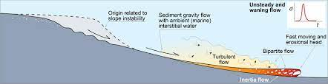

Four key components make coal – Underground decayed plant life converted into peat, time, pressure, and heat. With time, pressure, and heat, metamorphism occurs, and coal is form.

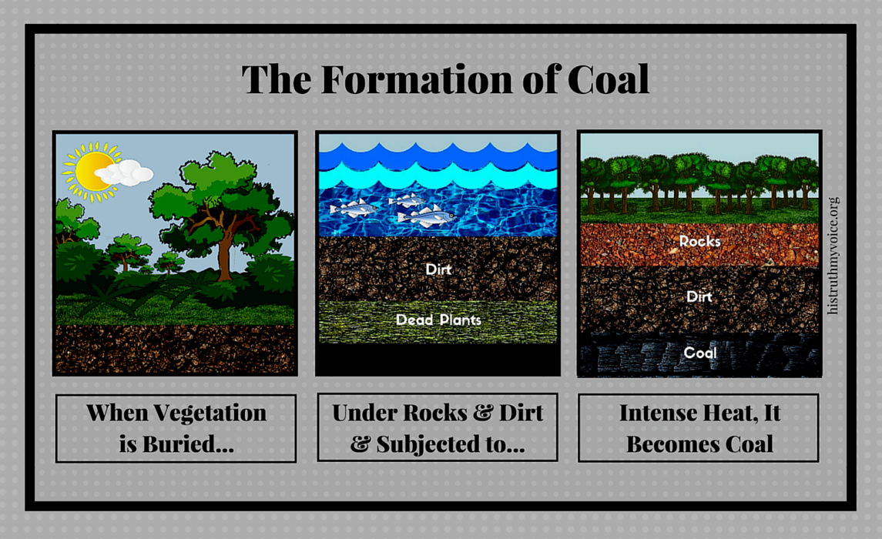

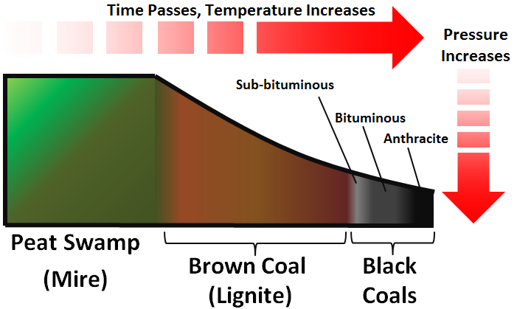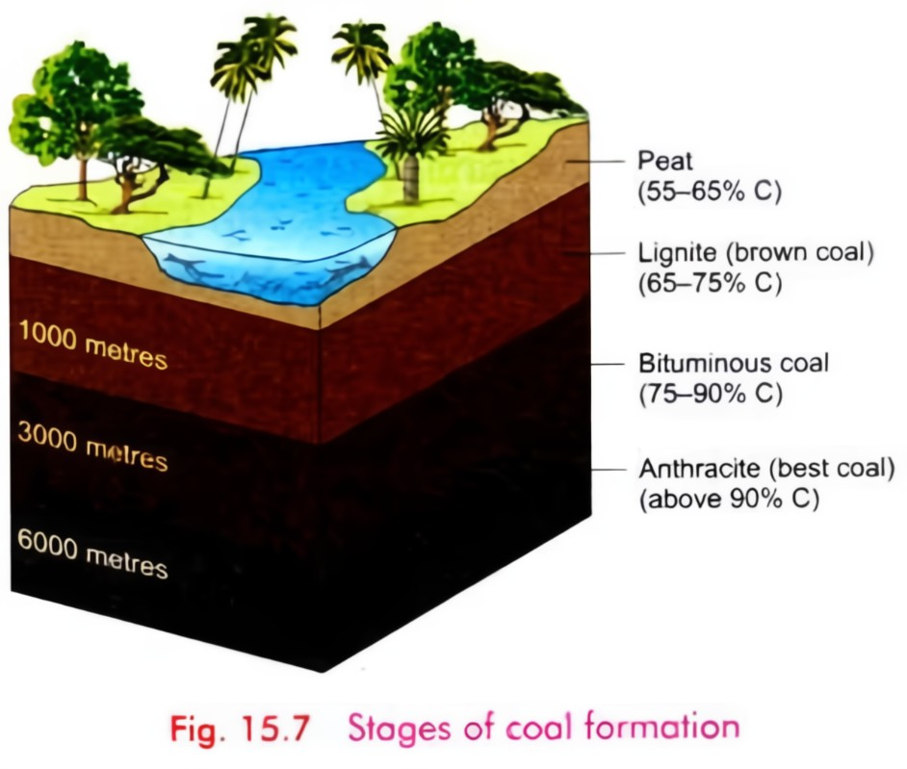

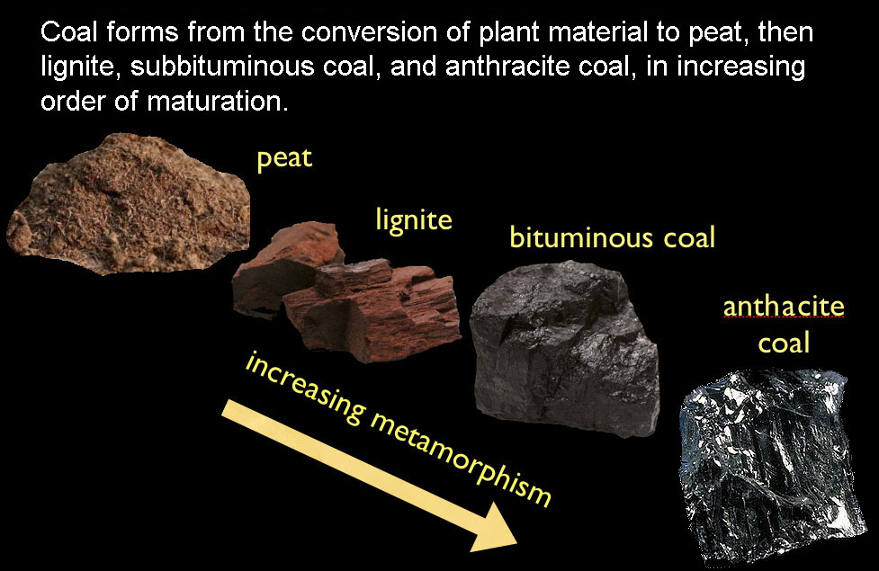

- Compare and contrast the four main types of coal, correctly identity their unique features, and the BTU’s they produce.
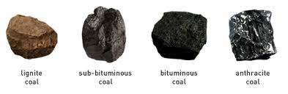
Their ranking depends on the types and amounts of carbon the coal contains to product the amount of heat energy. The heat energy produced is measured in BTU’s (British Thermal Unit) – the energy needed to raise the temperature of water by one-degree Fahrenheit.

Anthracite Coal

This coal has the highest percentage of carbon (86-97%) with the lowest volatile matter. It is a hard and brittle coal with a black lustrous look. It produces around 13,000 – 15,000 BTU’s. It is used to make coke, which is used for steel making.

Bituminous Coal

This coal has between 45-86% carbon. It is blocky in appearance with alternating layers of dull and shinny layers. Its BTU range is between 11,000-15,000. It is used for both steel making and electrical generation power plants.

Subbituminous Coal

This coal has between 35-45% carbon. It has a soft dull (lighter) black appearance. It produces around 8,500 – 13,000 BTU’s. Its low-to-moderate heating values is mainly used for electrical generation power plants

Lignite Coal

This coal has between 25-35% carbon. It is also known as brown coal. It has the less percentage of carbon and the lowest BTU value with up to 70% water. It is used mainly for electrical generation power plants

- List 5 major historic uses of coal.
- To generate electricity in power plants by thermal power generation (water to steam)
- In cement
- paper production,
- ceramic manufacture
- iron and steel production

6. List 3 advantages and 3 disadvantages of using coal as a fuel

Advantages
- It is available in an abundant supply
- It is an inexpensive form of energy
- It has a predictable level of energy through combustion
- It offers a rather low capital investment because it is an established industry
- It is easy to introduce scrubbers and filters can also capture the CO2
- It can be converted into different formats, solid, liquid, and gas
- Not depended on wind or solar
Disadvantages

- Not a renewable resource
- It has a high level of carbon dioxide per British Thermal Unit. Coal emissions are linked to health concerns - acid rain
- It produces coal ash. It is A byproduct of burning coal for power, that produces radiation. This ash then settles around the surrounding areas of the coal plant. According to Scientific American, a coal power plant can produce up to 100 times more radiation than a nuclear power plant. carcinogenic in that they cause cancer and cell mutations
- Coal mines cause relocation and destruction of wildlife and plants

https://vittana.org/14-advantages-and-disadvantages-of-coal#:~:text=Here%20Are%20the%20Advantages%20of%20Coal.%201%201.,to%20as%20CCS%2C%20is%20a%20...%20More%20items

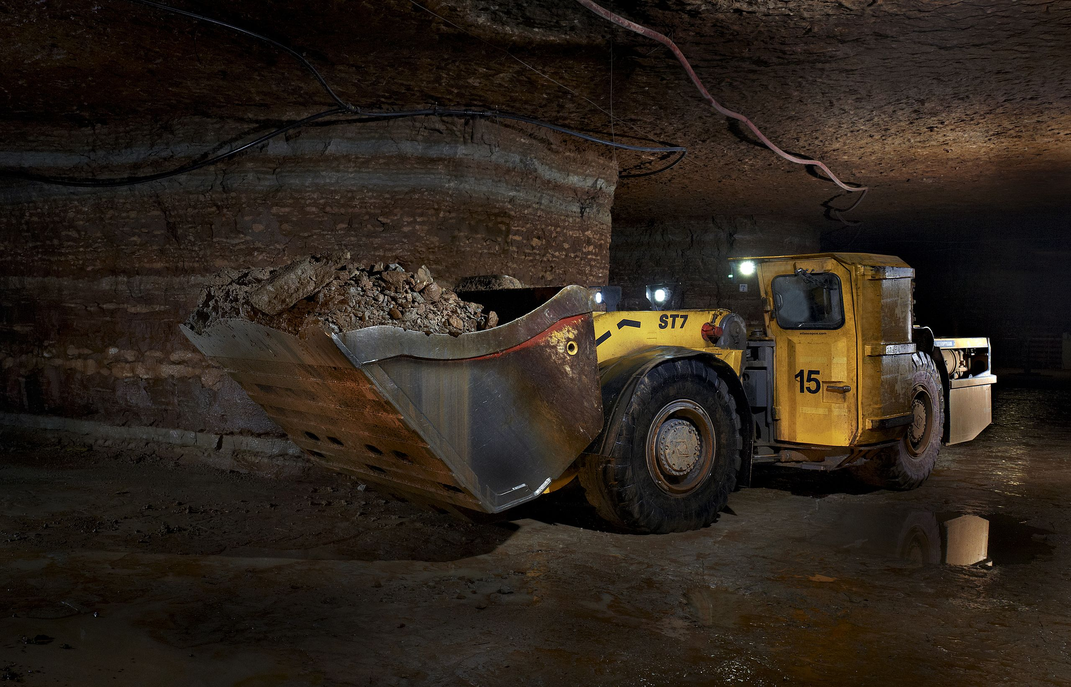
- Describe the 3 main methods that are used to mine for coal.
- Underground mining – this process is expensive and are often used to reach deeper deposits. In some countries, multiple types of coal mining are done according to their geological area. Underground mining is considered by many as one of the most dangerous forms of mining.
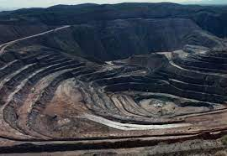
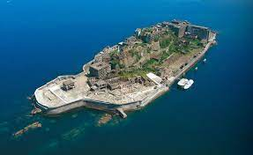
- Surface or open-pit mining - it is typically used for shallow retrieval deposits. In open-pit mining, roads surrounding the pit are created in levels called benches. This is done to safety haul the coal up to a main hopper(s) where the coal is crushed, and water from the coal is drained. Sometimes a conveyor system is used to haul the coal out of the pit. From the hopper, the coal is commonly sent to silos where they are dispersed to different forms of transportation.
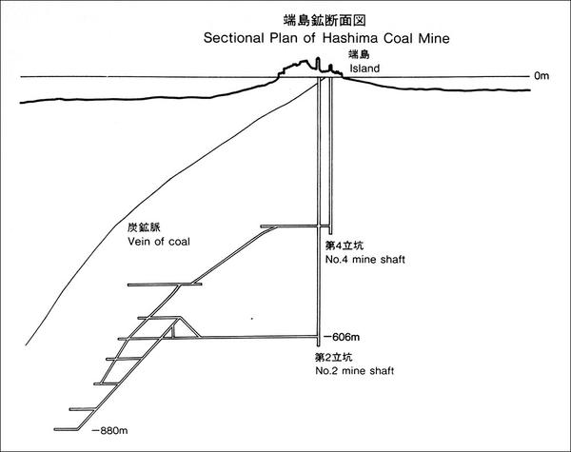
- Underwater mining – Shafts are drilled to reach the coal veins. Then they are retrieved by flowing exactors or other types of retrieval systems. Other underwater mines originate onshore and once the proper depth is established, digging moves towards the sea of ocean. This is like underground mining. The difference is water is above the shafts instead of earth.

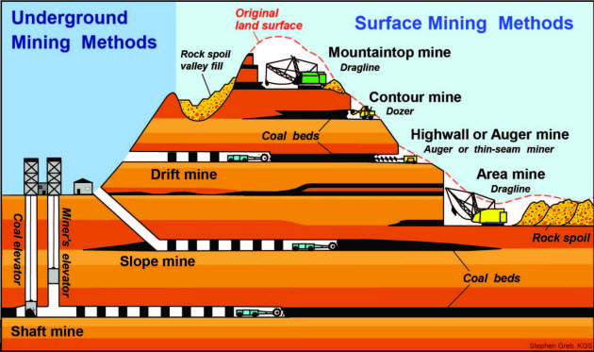

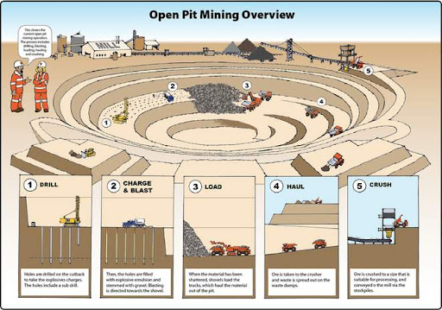

8. Discuss 3 major hazards of underground coal mining and what is done to reduce them.

- CCM – Coal Mine Methane – the gas deposits are highly flammable.
Solution – proper ventilation systems. Ventilation helps to reduce the confinement side of explosions. Also, by using capturing methods, the CCM is used for natural gas purposes.
- Lack of proper training on equipment or safety protocols
Solution – proper cross-training on various equipment and procedures to reduce possible injuries and/or hazardous conditions.
- Coal Dust Fires – if ignited, it quickly spreads and it difficult to stop. However, if one of the four conditions of what causes a fire (Fuel, heat, oxygen, and a chemical chain (leg) reaction) is eliminated, it slows or prevents a fire.
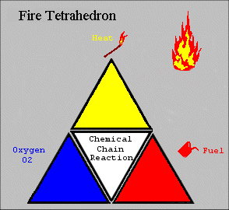
Solution – rock dusting or encapsulator agents
Rock dusting - is when limestone (rock dust) is sprayed in the mines to keep the coal dust down. This rock dust serves to inert the coal dust. If an explosion occurs, the rock dust absorbs the heat generated from an explosion and will either halt the chain reaction or reduce the force of the explosion.
Encapsulator agents – stops the chemical chain reaction from occurring.

- Evaluate the environmental impact concerns and restoration processes used in surface type coal mining.
Usually an Environmental Impact Statement (EIS) is needed for approval before coal mining is authorized. In the EIS, a plan is submitted for a reclamation process.

Once all the coal is removed, it is filled with dirt, then with overburden, and finally with topsoil. The topsoil is usually 2 feet thick and mixed with native seed of plants and shrubs. At times tree species are included in the reclamation process.

When the reclamation process is completed, continuous monitoring occurs to assure plant life is restored. At times, piles of rock are added to create habits for wildlife.

9. Do one of the following and write a one-page review of what you learned from the visit.

a) Tour a coal mine

b) Visit a coal mining museum

c) Watch a video on the mining of coal

Skill Level 1

